NAME:NOLEN MAKOKHA MACHUNGO
REGISTRATION NUMBER: C024/401445/2023
UNIVERSITY : COOPERATIVE UNIVERSITY OF KENYA
SCHOOL : SCHOOL OF COMPUTING AND MATHEMATICS
COURSE: BARCHELOR OF SCIENCE IN COMPUTER SCIENCE
UNIT : INTERNET APPLICATION PROGRAMMING
UNIT CODE:BCIT 2218
YEAR:2
SEMESTER: 2
ASSIGNMENT 2

Use a network packet sniffer (Wireshark or equivalent) to analyze HTTP headers.

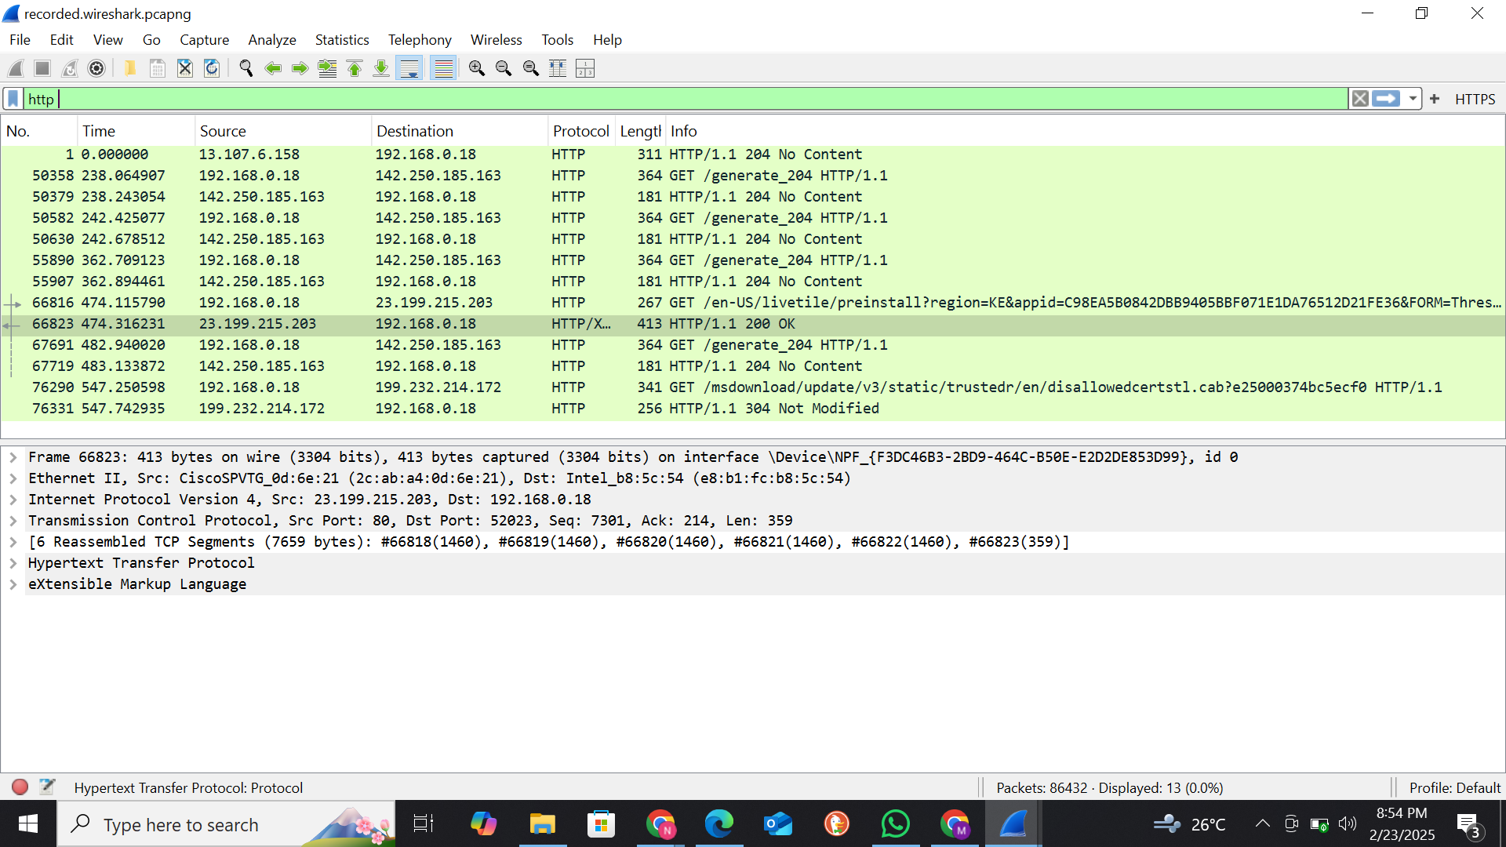

Capture an HTTP GET and POST request.


Identify: a) Request and response headers
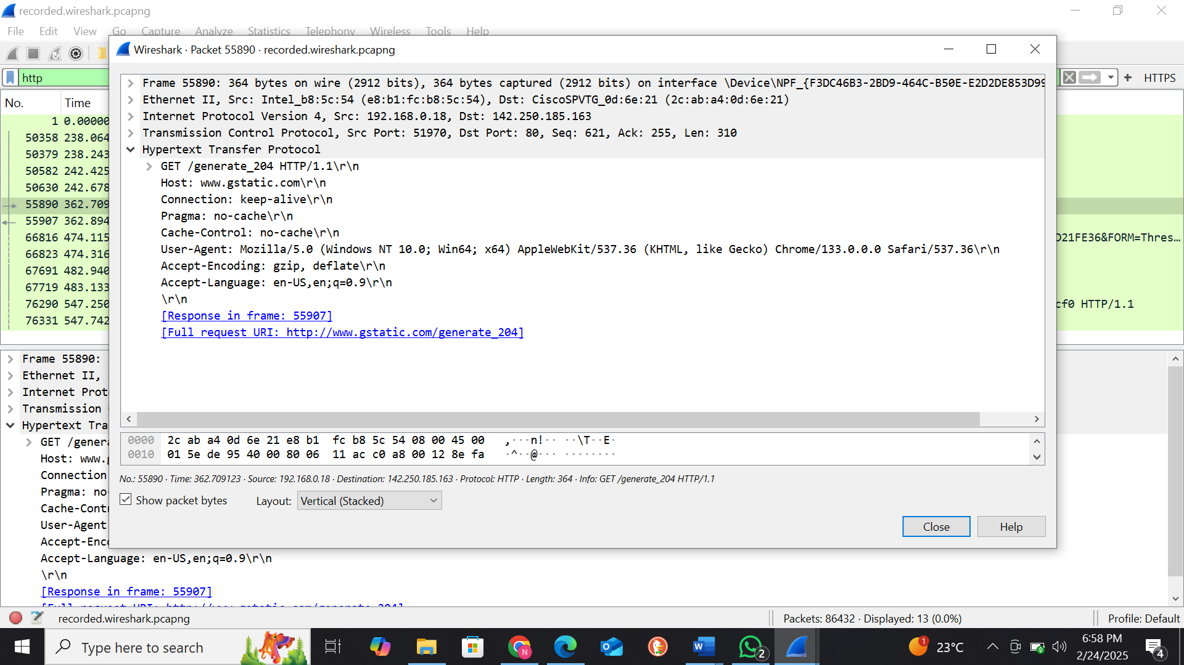
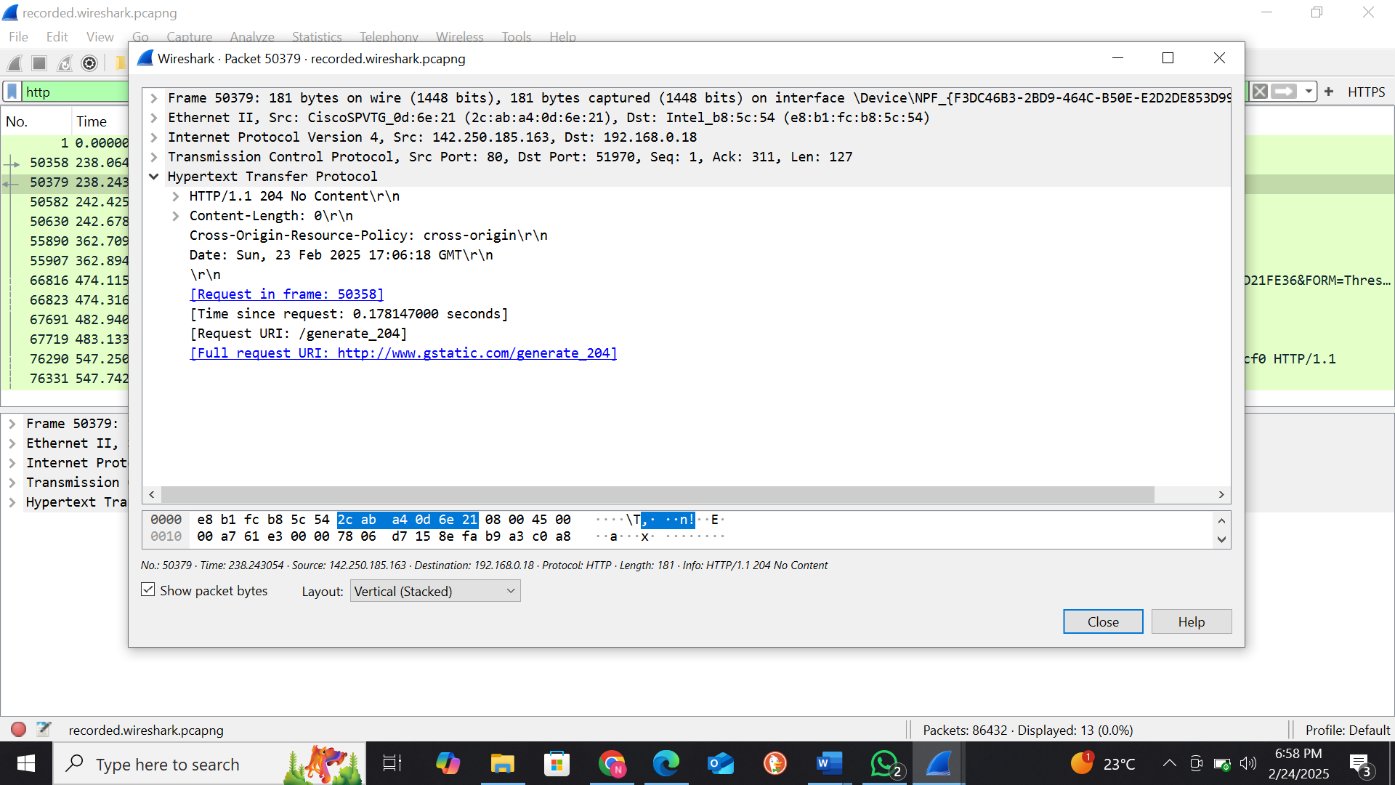

b) MIME type of the response.

c) HTTP status code and explanation. Submit a detailed report with screenshot
status code 200- Indicates the server has received and accepted the request
status code 204 -Indicates “No Content”

